SPOE Power Supply Switch Specifications

SPOE powered digital switch : 16+2+1=19 ports

TBC- 5FP4116N - 2GE ( as shown on the left ) TBC- 5FP4216N - 3PF ( as shown on the right )

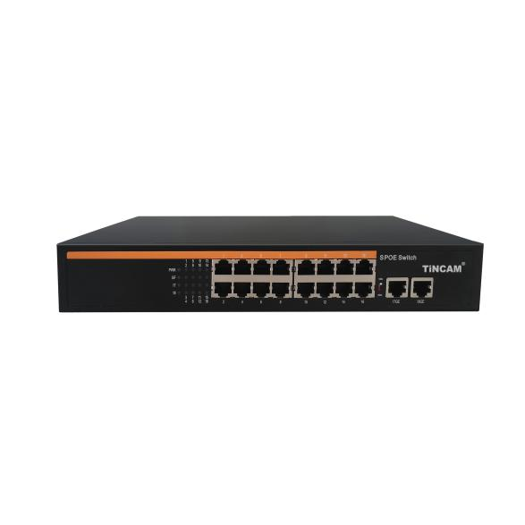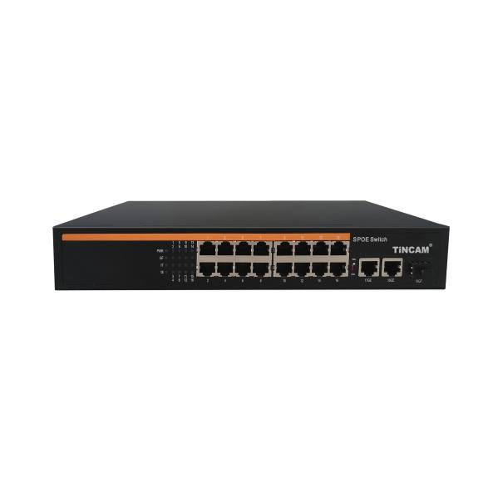
Product Overview
The TBC-5FP4116N series non-standard SP OE power supply switches feature 16 100M Ethernet ports and two 1000M adaptive uplink ports. Ports 1-16 support non-standard 15V or 24V SP OE power. Each port delivers up to 30W of SP OE power , for a maximum total output power of 150W , 200W, or 300W. As a non-standard SP OE power supply, it must be connected to a corresponding non-standard power-consuming device (such as a wireless bridge or building intercom) or equipped with a corresponding non-standard splitter cable for conversion to achieve SPOE power over the network cable. It can power various PD- adapted terminal devices through the network cable . If the RJ45 connector wiring sequence is not in pass-through mode, the powered device will not be able to power properly when the power-off protection function is activated during the switch startup process. This device meets the needs of network environments requiring high-density SP OE power supply and is widely used in smart buildings, intelligent low-voltage power systems, and other projects to build cost-effective digital network transmission .
Non-network-managed switches are plug-and-play, require no configuration, and are easy to use ( note: non-standard switches require straight-through RJ45 connectors to avoid power failure ) .

Features
- 100M access, dual electrical ports uplink (cascade application)
◇ It provides 16 10 /100M adaptive electrical ports + 2 10 /100/1000M adaptive Fast Ethernet electrical ports + 1 Gigabit SFP optical port, facilitating flexible on-site cascading networking and meeting the networking needs of various scenarios such as optical fiber transmission .
◇ All ports support non-blocking line-speed forwarding, making transmission smoother.
◇ Supports IEEE 802.3 , IEEE 802.3 U, IEEE 802.3x full-duplex flow control and Backpressure half-duplex flow control.

- SPOE power supply function
◇ 16 10/100Base-T X RJ45 ports support 15V or 24V SPOE power supply to meet the power supply needs of building intercom, security monitoring, wireless bridge , etc.
◇ The maximum SP O E output power of the whole machine is 300W ( 150W/200W optional ) , and the maximum PO E output power of a single port is 30W .
◇ Directly connect the SPOE power supply port of the SPOE switch to non-standard SPOE powered devices (building intercom) or SPOE switch + non-standard splitter (connecting cameras) in two ways, and cascade the dual electrical ports uplink or link to the aggregation switch to quickly realize SPOE network cable power supply and data transmission functions .
- Easy to operate
◇ Plug and play, no configuration required, simple and convenient.
◇ With long distance function switch, when turned on, ports 1-16 support 10M/250m long distance transmission;
understand the working status of the device through the power indicator (Power) and port status indicator .
- Stable and reliable equipment
◇ The host has low power consumption, fanless and silent design, and metal casing to ensure stable operation of the product.
◇ Adopt reasonable built -in power supply structure and high redundancy design to provide long -lasting and stable P O E power supply output.
◇ The equipment fully complies with ISO:9001, CE, FCC, ROHS and other requirements, and is safe and reliable to use.

Product Technology and Specifications
Model | TBC-5FP4116N-2GE | TBC-5FP4116N-3PF
Fixed port | 16 10/100Base-TX S POE ports (Data/Power)  2 10/100/1000 Base-T uplink RJ45 ports (Data) | 16 10/100Base-TX S POE ports (Data/Power)  2 10/100/1000 Base-T uplink RJ45 ports (Data)  1 Gigabit SFP optical port (fiber connection)
SPOE port | 1- 16 ports support 15V or 24V non- standard S POE power supply
Function switch ( Extended ) | After opening, ports 1-16 support 10M/250m long-distance power supply and transmission
Function switch ( Extended ) | Note: When the switch status changes, you must restart the switch for the switch function to take effect;
Network Protocol | IEEE802.3 10BASE-T; IEEE802.3u 100Base-TX; IEEE802.3ab 1 0 00Base-T ; IEEE802.3x
Power supply standards | Non-standard mandatory DC15V or 24V SPOE power supply;
Network port characteristics | 10/100BaseT(X) or 10/100 /1000BaseT auto-sensing, full/half duplex MDI / MD IX adaptive port
Forwarding Mode | Store and forward (full line speed)
Backplane bandwidth | 9.2 Gbps
Packet forwarding rate | 7 Mpps
MAC address | 16 K
Packet forwarding cache | 4 M
Twisted pair transmission | 10BASE-TX: Cat5 or later UTP (≤ 25 0 meter)  100BASE-TX: Cat5 or later UTP(≤100 meter)  100 0 BASE-T: Cat5e or later UTP(≤100 meter)
Power supply pin (optional) | Support 1 / 2 (+), 3 / 6 (-) , 4-core power supply
Power supply pin (optional) | Supports 4/5 ( +), 7/8 (-) , 4 -core power supply
AF/AT | 15.4 W/ 25.5 W
Total power | 150W /200W/300W ( AC100-240V)
Power consumption of the whole machine | Standby power consumption: < 15 W; Full load power consumption: < 150 W
LED indicators | Power indicator: PWR (green); Network indicator: ( green ) ;
Supporting power supply | Built -in switching power supply , AC: 100 ~ 240V 50-60Hz 6.25A
Operating temperature/humidity | -20～+55°C; 5%～90% RH non-condensing
Storage temperature/humidity | -40～+75°C; 5%～95% RH non-condensing
Dimensions | 310 * 182 * 4.4 mm (L*W*H)
Net weight/gross weight | ＜ 1.7 kg / ＜ 2.2 kg
Installation | Desktop, wall-mounted, rack-mounted (can be mounted on a cabinet with ears)
Lightning protection/protection level | Port lightning protection: 4KV 8/20us;  Protection level: IP30
Safety Certification | CE mark, commercial; CE/LVD EN60950;  FCC Part 15 Class B; RoHS;
Warranty period | 12-month warranty and lifetime maintenance !
Packing list
packing list | Item Name | unit | quantity
packing list | 16 -port S POE power supply switch | piece | 1
packing list | AC power cord | piece | 1
packing list | Hardware installation kit | piece | 1
packing list | Quick Start Guide | piece | 1
packing list | Warranty card and certificate | piece | 1
Ordering Information
Device Model | Specifications
TBC-5FP4116N15-2GE | 16 10 /100M ports + 2 10 /100/1000M port S POE switch, of which ports 1-16 support 15V non- standard POE power supply, support 4/5 ( +), 7/8 (-) , 4 - core power supply, and support 10M/ 250m long-distance transmission, with a built-in 150W power supply.
TBC-5FP4116N20-2GE | 16 10 /100M ports + 2 10 /100/1000M port S POE switch, of which ports 1-16 support 15V non- standard POE power supply, support 4/5 ( +), 7/8 (-) , 4 - core power supply, and support 10M/ 250m long-distance transmission, with built-in 200W power supply.
TBC-5FP4116N30-2GE | 16 10 /100M ports + 2 10 /100/1000M port S POE switch, of which ports 1-16 support 15V non- standard POE power supply, support 4/5 ( +), 7/8 (-) , 4 - core power supply, and support 10M/ 250m long-distance transmission, with a built-in 300W power supply.
TBC-5FP4116N15-3PF | 16 10/100M ports + 2 10 /100/1000M ports + 1 Gigabit SFP optical port S POE switch, of which ports 1-16 support 15V non-standard POE power supply, support 4/5 ( +), 7/8 (-) , 4 - core power supply, support 10M/250m long-distance transmission, and built-in 150W power supply.
TBC-5FP4116N20-3PF | 16 10/100M ports + 2 10 /100/1000M ports + 1 Gigabit SFP optical port S POE switch, of which ports 1-16 support 15V non-standard POE power supply, support 4/5 ( +), 7/8 (-) , 4 - core power supply, support 10M/250m long-distance transmission, and built-in 200W power supply.
TBC-5FP4116N30-3PF | 16 10/100M ports + 2 10 /100/1000M ports + 1 Gigabit SFP optical port S POE switch, of which ports 1-16 support 15V non-standard POE power supply, support 4/5 ( +), 7/8 (-) , 4 - core power supply, support 10M/250m long-distance transmission, and built-in 300W power supply.
TBC-5FP4216N15-2GEV | 16 10 /100M ports + 2 10 /100/1000M port S POE switch, of which ports 1-16 support 24V non- standard POE power supply, support 4/5 ( +), 7/8 (-) , 4 - core power supply, and support 10M/ 250m long-distance transmission, with a built-in 150W power supply.
TBC-5FP4216N20-2GEV | 16 10 /100M ports + 2 10 /100/1000M port S POE switch, of which ports 1-16 support 24V non- standard POE power supply, support 4/5 ( +), 7/8 (-) , 4 - core power supply, and support 10M/ 250m long-distance transmission, with a built-in 200W power supply.
TBC-5FP4216N30-2GEV | 16 10 /100M ports + 2 10 /100/1000M port S POE switch, of which ports 1-16 support 24V non- standard POE power supply, support 4/5 ( +), 7/8 (-) , 4 - core power supply, and support 10M/ 250m long-distance transmission, with a built-in 300W power supply.
TBC-5FP4216N15-3PFV | 16 10/100M ports + 2 10 /100/1000M ports + 1 Gigabit SFP optical port S POE switch, of which ports 1-16 support 24V non-standard POE power supply, support 4/5 ( +), 7/8 (-) , 4 - core power supply, support 10M/250m long-distance transmission, and built-in 150W power supply.
TBC-5FP4216N20-3PFV | 16 10/100M ports + 2 10 /100/1000M ports + 1 Gigabit SFP optical port S POE switch, of which ports 1-16 support 24V non-standard POE power supply, support 4/5 ( +), 7/8 (-) , 4 - core power supply, support 10M/250m long-distance transmission, and built-in 200W power supply.
TBC-5FP4216N30-3PFV | 16 10/100M ports + 2 10 /100/1000M ports + 1 Gigabit SFP optical port S POE switch, of which ports 1-16 support 24V non-standard POE power supply, support 4/5 ( +), 7/8 (-) , 4 - core power supply, support 10M/250m long-distance transmission, and built-in 300W power supply.
TBC-5FP4216N15-2GX | 16 10 /100M ports + 2 10 /100/1000M port S POE switch, of which ports 1-16 support 24V non- standard POE power supply, support 1/2 ( +), 3/6 (-) , 4 - core power supply, and support 10M/ 250m long-distance transmission, with built-in 150W power supply.
TBC-5FP4216N20-2GX | 16 10 /100M ports + 2 10 /100/1000M port S POE switch, of which ports 1-16 support 24V non- standard POE power supply, support 1/2 ( +), 3/6 (-) , 4 - core power supply, and support 10M/ 250m long-distance transmission, with built-in 200W power supply.
TBC-5FP4216N30-2GX | 16 10 /100M ports + 2 10 /100/1000M port S POE switch, of which ports 1-16 support 24V non- standard POE power supply, support 1/2 ( +), 3/6 (-) , 4 - core power supply, and support 10M/ 250m long-distance transmission, with built-in 300W power supply.
TBC-5FP4216N15-3PFX | 16 10/100M ports + 2 10 /100/1000M ports + 1 Gigabit SFP optical port S POE switch, of which ports 1-16 support 24V non-standard POE power supply, support 1/2 ( +), 3/6 (-) , 4 - core power supply, support 10M/250m long-distance transmission, and built-in 150W power supply.
TBC-5FP4216N20-3PFX | 16 10/100M ports + 2 10 /100/1000M ports + 1 Gigabit SFP optical port S POE switch, of which ports 1-16 support 24V non-standard POE power supply, support 1/2 ( +), 3/6 (-) , 4 - core power supply, support 10M/250m long-distance transmission, and built-in 200W power supply.
TBC-5FP4216N30-3PFX | 16 10/100M ports + 2 10 /100/1000M ports + 1 Gigabit SFP optical port S POE switch, of which ports 1-16 support 24V non-standard POE power supply, support 1/2 ( +), 3/6 (-) , 4 - core power supply, support 10M/250m long-distance transmission, and built-in 300W power supply.

