10-Port 10/100Mbps POE Fiber Switch

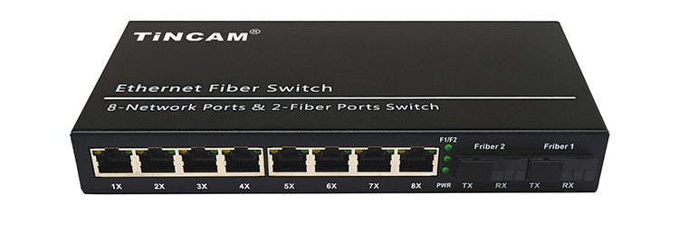
Product Description

The TBC-PSF4328ES20AB POE Switch supports the IEEE802.3af/at power over Ethernet standard with a power distance of 100 meters and only powers 802.3af/at terminal devices, so there is no need to worry about compromising proprietary standards for POE or non-POE devices. In addition, the POE device stops supplying power when it is not connected. These devices, which are far from the power outlet, are suitable for hanging on the wall or on the ceiling, and the POE eliminates the need to connect the power outlets for these devices, making the connection to equipment that is difficult to connect to AC power more flexible and with minimal installation costs. This series POE Powered switches are ideal selection for small business networks that want to use the economic deployment of wireless access points (AP) and IP-based network surveillance cameras .
Product characteristics
- Support full port IEEE802.3af/at standard
- Transmit Ethernet data through a network cable and provide power supply function;
- It can automatically detect and identify PD power receiving equipment that
meets the IEEE802.3af/IEEE802.3at standard;
- Support port power supply priority to ensure continuous power supply at network gateways;
- It has a short-circuit protection function. When the current is too large or the PD device fails, the power supply will be stopped to protect the PD powered device;
- It comes with energy-saving and environmental protection, supports automatic standby mode and cable length and other functions, that is, automatically standby to save energy when the port is not connected. When the cable length is less than 10 meters, it provides the power transmission rate;
- Full-series product line: 1-8 POE power supply port selection, 1-2 SC optical port cascade applications;
- POE cable transmission distance can reach 100 meters, and optical fiber transmission distance can reach 20km

Stable and reliable equipment

- Simple operation and strong expansibility;
- Easy to use, no need to configure, plug and play, strong compatibility, no burning device;
- High speed transmission, no packet loss, flexible expansion, so that the network is not limited by power line layout, saving user costs;
- Meet the demand of high density Poe power supply network environment;
- It is suitable for financial institutions, government agencies, hotels, shopping malls, campuses, hospitals and small and medium-sized enterprises to establish a cost-effective network.
Application
Application

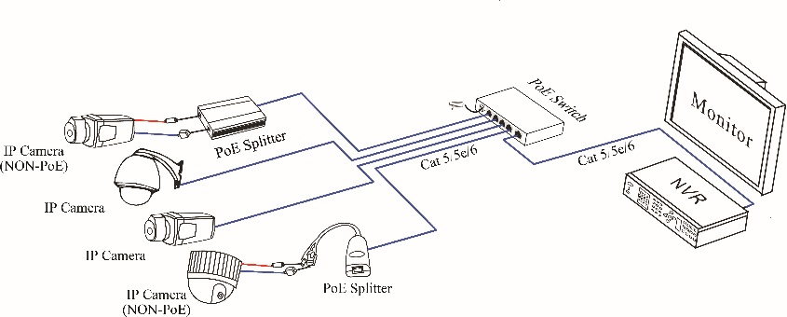

Specification
Item |  | Description
Power | Input voltage | AC100-240V
Power | Output voltage | DC48V~52V
Power | Total Power | 120W, Built-in power supply
Network Connector | Ethernet Port | 1～8 Port : 10/100Mbps POE Ethernet Port
Network Connector | Ethernet Port | 9~10 Port : 10/100Mbps SC Fiber Ports
Network Connector | Transmission Distance | 1～8 Port: 0~100m
Network Connector | Transmission Distance | 9~10 Port : 0~20km
Network Connector | Transmission Medium | Cat5/5e/6 standard network cable  Single-mode simplex fiber optic patch cord
Network Switch | Network Standard | IEEE802.3X, IEEE 802.3i 10BASE-T, IEEE 802.3u 100BASE-TX, 100BASE-BX，IEEE802.1Q, IEEE802.3az.
Network Switch | Switching Capacity | 2Gbps
Network Switch | Packet Forwarding Rate | 1.488Mpps
Power Over Ethernet | POE Standard | IEEE 802.3af/at
Power Over Ethernet | POE Power Consumption | af≤15.4W , at≤30W , (POE port)
Power Over Ethernet | Connection Pins | Data pins:100M:12 +/36-, power pins: 12+36-
LED Status Indicator | POE Ethernet LED Indicator | POE: 8 yellow lights indicate that the POE is power on;
LED Status Indicator | POE Ethernet LED Indicator | Ethernet: 8 green lights indicate that the Ethernet link and act;
LED Status Indicator | Fiber Ports LED Indicator | F1/F2 green lights indicate that the Ethernet link and act
LED Status Indicator | Power LED Indicator | Power: 1 red light indicates that the power normal work;
Environmental | Working temperature | -30～+80°C
Environmental | Relative humidity | 5%～90% RH non-condensing
Environmental | Storage temperature | -40～+85°C
Environmental | Storage humidity | 5%～95% RH non-condensing
Mechanical | Dimension (L×W×H) | 202*140*45mm
Mechanical | Color | Black
Mechanical | Weight | 1.1kg
Stability | MTBF | >30000h
Installation Step
Please check below device and accessories before installation, if there are missing, please contact with your supplier.
- POE Switch 1 PCS
- Power Adapter/Power Adapter Cable 1 PCS
- User Manual 1 PCS

Please follow the following steps
◆ Please turn off the signal source and the device's power before installing, installation with power on may damage the device;
◆ Use the network cables to connect the IP cameras with Ethernet switch's every POE port;
◆ Use network cable to connect Ethernet switch’s UPLINK port with NVR or Other Device;
◆ Connect Ethernet switch with power adapter;
◆ Check if the installation is correct and device is good, make sure all the connection is reliable and power for the system;
◆ Make sure every network device has power supply and work normally.

Problem Examination
Please remove the problem according to the following steps
◆ Please confirm if the device installation is correct;
◆ Please confirm if the RJ45 reach the standard of EIA/TIA568A OR 568B;
◆ The maximum transmission distance depends on the signal source and cable quality, please do not over the maximum transmission distance;
◆ Please replace a normal device with a failure one to check if the device is broken;
◆ If the problem still exist , please contact the factory.

