SPOE Power Supply Switch Specifications

SPOE powered digital switch : 6+2=8 ports

TBC- 5 FP4108 N ( as shown ) 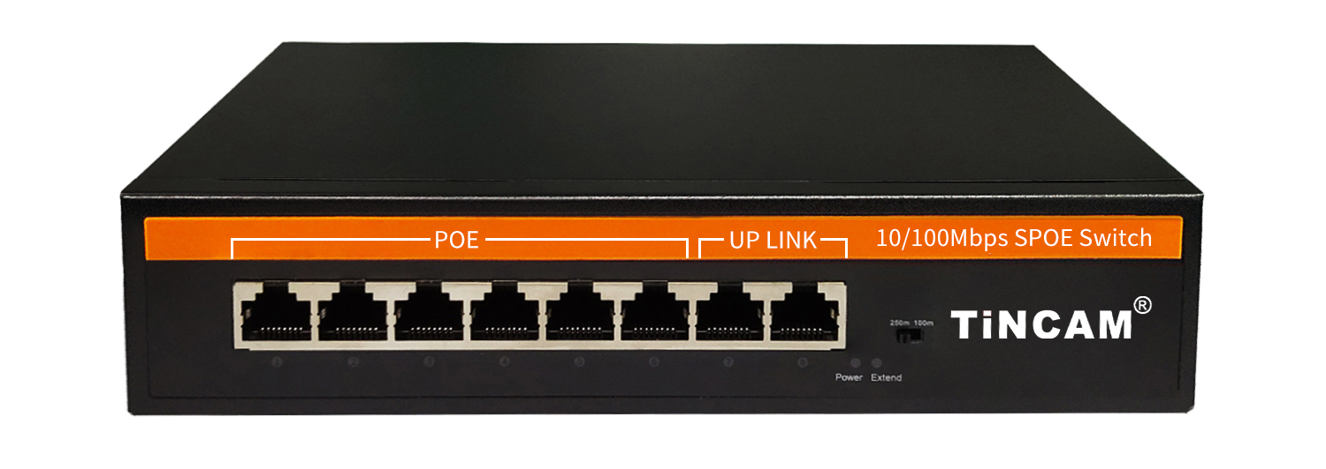
Product Overview
The TBC-5FP4108 series non-standard SP O E powered switches feature six 100M Ethernet ports and two 100M adaptive uplink ports. Ports 1-6 support non-standard 15V or 24V SP O E power , with a single-port SP O E output power of 30W and a total maximum SP O E output power of 48/ 96W. As a non-standard SP O E power supply, it must be connected to a corresponding non- standard power - consuming device (such as a wireless bridge or building intercom) or equipped with a corresponding non-standard splitter for conversion, thus achieving SPOE power over the network cable . It can power various PD adapter devices through the network cable . If the RJ45 connector wiring sequence is not in straight-through mode, the powered device will not be able to power properly when the power-off protection function is activated during the power-on process. This series meets the needs of network environments requiring high-density SP O E power supply and is widely used in smart buildings, intelligent low-voltage power projects, and other economical and efficient digital network transmission .
Non-network-managed switches are plug-and-play, require no configuration, and are easy to use ( note: non-standard switches require straight-through RJ45 connectors to avoid power failure ) .

Features
- 100M access, dual electrical ports uplink (cascade application)
◇ It provides six 10 /100M adaptive electrical ports with power-off protection and two 10/100M adaptive Fast Ethernet electrical ports, facilitating flexible on-site cascading networking and meeting the networking needs of various scenarios such as optical fiber transmission .
◇ All ports support non-blocking line-speed forwarding, making transmission smoother.
◇ Supports IEEE 802.3 , IEEE 802.3 U, IEEE 802.3x full-duplex flow control and Backpressure half-duplex flow control.

- SP O E power supply function
◇ 6 10/100Base-T X RJ45 ports support 15V or 24V SPOE power supply to meet the power supply needs of building intercom, security monitoring, wireless bridge , etc.
◇ The maximum SP O E output power of the whole device is 48/96 W, and the maximum PO E output power of a single port is 30 W. Port protection power supply function;
◇ Directly connect the SPOE power supply port of the SPOE switch to non-standard SPOE powered devices (building intercom) or SPOE switch + non-standard splitter (connecting cameras) in two ways, and cascade the dual electrical ports uplink or link to the aggregation switch to quickly realize SPOE network cable power supply and data transmission functions .
- Easy to operate
◇ Plug and play, no configuration required, simple and convenient.
◇ With long distance function switch, when turned on, ports 1-6 support 10M/250m long distance transmission;
understand the working status of the device through the power indicator (Power) and port status indicator .
- Stable and reliable equipment
◇ The host has low power consumption, fanless and silent design, and metal casing to ensure stable operation of the product.
◇ Adopt reasonable built -in power supply structure and high redundancy design to provide long -lasting and stable P O E power supply output.
◇ The equipment fully complies with ISO:9001, CE, FCC, ROHS and other requirements, and is safe and reliable to use.

Product Technology and Specifications
Model | TBC-5FP4108N
Fixed port | 6 10/100Base-TX SPOE ports (Data/Power)  2 10/100Base-T uplink RJ45 ports (Data)
SPOE port | Ports 1-6 support 15V or 24V non-standard SPOE power supply
Function switch (Extender) | After opening, ports 1-6 support 10M/250m long-distance power supply and transmission
Function switch (Extender) | Note: When the switch status changes, you must restart the switch for the switch function to take effect;
Network Protocol | IEEE802.3 10BASE-T; IEEE802.3u 100Base-TX; IEEE802.3ab 1 0 00Base-T ; IEEE802.3x
Power supply standards | Non-standard mandatory DC15V or 24V SPOE power supply;
Network port characteristics | 10/100BaseT(X) or 10/100 /1000BaseT auto-sensing, full/half duplex MDI / MD IX adaptive port
Forwarding Mode | Store and forward (full line speed)
Backplane bandwidth | 1.2 Gbps
Packet forwarding rate | 0.9 Mpps
MAC address | 1 K
Packet forwarding cache | 4 M
Twisted pair transmission | 10BASE-TX: Cat5 or later UTP (≤ 25 0 meter)  100BASE-TX: Cat5 or later UTP(≤100 meter)
Power supply pin (optional) | Support 1 / 2 (+), 3 / 6 (-) , 4-core power supply
Power supply pin (optional) | Supports 4/5 ( +), 7/8 (-) , 4 -core power supply
AF/AT | 15.4 W/ 25.5 W
Total power | 48/96 W (AC100-240V)
Power consumption of the whole machine | Standby power consumption: < 3 W; Full load power consumption: < 60 W
LED indicators | Power indicator: PWR (green); Network indicator: ( green ) ;
Supporting power supply | Built -in switching power supply , AC: 100 ~ 240V 50-60Hz 5A
Operating temperature/humidity | -20～+55°C; 5%～90% RH non-condensing
Storage temperature/humidity | -40～+75°C; 5%～95% RH non-condensing
Dimensions | 202 * 140 * 4.5 mm (L*W*H)
Net weight/gross weight | ＜ 0.6 kg / ＜ 1 kg
Installation | Desktop, wall-mounted
Lightning protection/protection level | Port lightning protection: 4KV 8/20us;  Protection level: IP30
Safety Certification | CE mark, commercial; CE/LVD EN60950;  FCC Part 15 Class B; RoHS;
Warranty period | 12-month warranty and lifetime maintenance !
Packing list
packing list | Item Name | unit | quantity
packing list | 8 -port non-standard S POE switch with power supply protection function | piece | 1
packing list | AC power cord | piece | 1
packing list | Quick Start Guide | piece | 1
packing list | Warranty card and certificate | piece | 1
Ordering Information
Device Model | Specifications
TBC-5FP4108N4 | 6 10/100M ports + 2 10 /100M port S POE switch, of which ports 1-4 support 15V non- standard POE protected power supply, support 4/5 ( +), 7/8 (-) , 4 - core power supply, and support 10M/250m long-distance transmission, with built-in 48W power supply.
TBC-5FP4108N9 | 6 10/100M ports + 2 10 /100M port S POE switch, of which ports 1-4 support 15V non- standard POE protected power supply, support 4/5 ( +), 7/8 (-) , 4 - core power supply, and support 10M/250m long-distance transmission, with built-in 96W power supply.
TBC-5FP4208N-X4 | 6 10/100M ports + 2 10 /100M port S POE switch, of which ports 1-6 support 24V non- standard POE power supply, support 4/5 ( + ), 7/8 (-) , 4 - core power supply, and support 10M/250m long-distance transmission, with built-in 48W power supply .
TBC-5FP4208N-X | 6 10/100M ports + 2 10 /100M port S POE switch, of which ports 1-6 support 24V non- standard POE power supply, support 4/5 ( + ), 7/8 (-) , 4 - core power supply, and support 10M/250m long-distance transmission, with built-in 96W power supply .
TBC-5FP4208N4V | 6 10/100M ports + 2 10 /100M port S POE switch, of which ports 1-6 support 24V non- standard POE power supply, support 1/2 ( + ), 3/6 (-) , 4 - core power supply, and support 10M/250m long-distance transmission, with built-in 48W power supply .
TBC-5FP4208N9V | 6 10/100M ports + 2 10 /100M port S POE switch, of which ports 1-6 support 24V non- standard POE power supply, support 1/2 ( + ), 3/6 (-) , 4 - core power supply, and support 10M/250m long-distance transmission, with built-in 96W power supply .

