Full Gigabit 32 -port Smart POE Switch
The TBC-PSF5624U40-4PM series full-Gigabit POE switch is a Tianbo Communication-innovated design specifically developed to meet PoE power supply requirements. It utilizes the latest high-speed Ethernet switching chips and an ultra-high backplane bandwidth design, offering extremely fast data processing and smooth data transmission. It features 24 RJ45 POE ports, four RJ45 Gigabit uplink electrical ports, and four Gigabit uplink SFP optical ports, utilizing a 4+4 uplink multiplexing configuration. All 24 RJ45 ports support IEEE 802.3af/at PoE, with a maximum power output of 15.4W/30W per port, for a total of 400W. It automatically detects and identifies IEEE 802.3af/at-compliant powered devices and prioritizes power delivery via the network cable.
Product images:
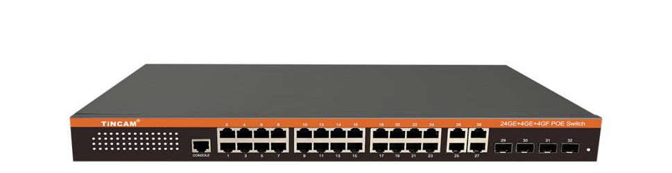
1U standard size 32 ports = 24+4+4 layout
Product Description:
Excellent port performance
Provides 24 10/100/1000Mpbs RJ45 adaptive high-speed forwarding data without packet loss RJ45 ports.
Provides 4 10/100/1000Mpbs RJ45 uplink ports + 4 SFP optical/electrical multiplexing ports;
Each port supports MDI/MDIX automatic flip and auto-negotiation, and supports IEEE 802.3x full-duplex flow control and Backpressure half-duplex flow control
Excellent PoE power supply performance
24 10/100/1000Mpbs RJ45 ports support PoE power supply, meeting the PoE power supply needs of scenarios such as security monitoring, teleconferencing systems, and wireless coverage APs.
Complying with IEEE 802.3af/at PoE power supply standards, the entire device PoE output power reaches 400W, and the maximum PoE output power of a single port is 15.4W/30W.
Automatically identifies PoE devices and provides power without damaging non-PoE devices.
PoE ports support a priority mechanism. When the remaining power is insufficient, the power supply of high-priority ports is prioritized to prevent equipment from overloading.
Working Mode
Standard switching mode: all ports communicate freely, suitable for general data transmission environment;
Video surveillance mode: specially designed for surveillance applications to improve the freezing and mosaic phenomena in the surveillance network.
VLAN isolation mode---suppresses network storms and improves network performance.
Stable and reliable equipment
The host has a low power consumption and silent design to ensure stable operation of the product.
It uses a self-developed power supply with a high redundancy design to provide long-term stable 120W PoE power output.
The equipment meets the national CCC standards, fully complies with safety regulations, and is safe and reliable to use.
Simple operation and strong scalability
Easy to use, no configuration required, plug and play, strong compatibility, no device burnout
High-speed transmission, no data packet loss, flexible expansion, so the network is not restricted by power line layout, saving user costs
Meet the network environment that requires high-density PoE power supply
It is suitable for financial institutions, government agencies, hotels, shopping malls, campuses, hospitals and small and medium-sized enterprises to build cost-effective networks.
Product parameters:
Network Standards | IEEE 802.3, IEEE 802.3u, IEEE 802.3x, IEEE 802.3af, IEEE 802.3at
Ports | 24 10/100/1000Mbps RJ45 ports  4 10/100/1000Mbps RJ45 uplink ports + 4 uplink SFP optical/electrical multiplexer ports
POE power supply | 24 10/100/1000Mbps RJ45 ports support PoE power supply  The maximum power supply of the whole machine is 400W  a single port is 15.4W/30W
POE connection | 1-24 ports support IEEE802.3af/at  Supports 12+ and 36-power supply lines and 8-core data transmission  End span transmission, transmission distance 100m
indicator light | Each port has one LINK/ACT.1000Mbps  POE Status indicator, whole device power indicator
Performance | Store and Forward  Support 8K MAC address table depth  64Gbps backplane bandwidth,
Forwarding rate | 10Mbps:14880pps  100Mbps:14880pps  1000BASE-T: 1488095pps/port
Port Function | Power supply priority mechanism, fast forwarding, MAC automatic learning and aging  IEEE802.3X full-duplex flow control and backpressure half-duplex flow control
Usage Environment | Working temperature: -10℃--55℃
Power supply and power | Built-in power supply  220V, 50HZ  ≥400W
Weight | 5KG

